5th Grade Obstacle Course
Date Due: Friday October 17th

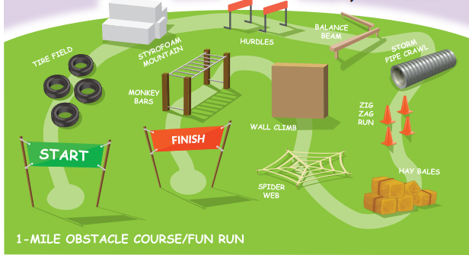

Task - Create an obstacle course and time yourself going through it . Keep trying to lower your time! The goal is to get your heart pumping and keeping it elevated (ideally for 20 - 60 minutes each day)

You must design and video yourself doing the course and email it to Mr. Turnbull. bturnbull8656@olhamptons.org Try and get your family members to get active with you!

Your course can be in a backyard, your house, around the edges of your parking lot (be careful-have an adult help you!), at a local park or school, along the sidewalk, etc.

The Obstacle Course should use some of these elements: jumping, kicking, running, skipping, throwing, hopping, balancing and catching. Exercises that can be used are jumping jacks, push - ups, sit- ups , burpees, mountain climbers, tuck jumps. Make sure there is a warm-up period and a cooldown period. Lastly, have fun!

